Project Design Phase-II
Solution Requirements (Functional & Non-functional)

Date | 19 July 2026
Team ID
Project Name | Nightjar & Co. – MERN BookStore
Maximum Marks | 4 Marks

Functional Requirements
FR No. | Functional Requirement (Epic) | Sub Requirement (Story / Sub-Task)
FR-1 | User Registration | Registration using name, email, and password
 |  | Input validation during registration
 |  | Password encryption using bcrypt
FR-2 | User Authentication | User login using email and password
 |  | JWT-based authentication
 |  | Protected routes for authenticated users
FR-3 | Book Management | Display all books
 |  | View book details
 |  | Search books by title
 |  | Filter books by category
FR-4 | Shopping Cart | Add books to cart
 |  | Remove books from cart
 |  | View cart items
FR-5 | Admin Book Management | Add new books
 |  | Update existing books
 |  | Delete books
FR-6 | User Interface | Responsive design
 |  | Navigation using React Router
 |  | User-friendly interface

Non-functional Requirements
NFR No. | Non-Functional Requirement | Description
NFR-1 | Usability | The application provides a simple, intuitive, and responsive interface that enables users to browse, search, and purchase books with minimal effort.
NFR-2 | Security | User passwords are encrypted using bcrypt, and authenticated sessions are protected using JWT-based authentication.
NFR-3 | Reliability | The system consistently performs user authentication, book retrieval, and cart operations while maintaining data integrity.
NFR-4 | Performance | REST APIs are optimized to provide quick responses for browsing books, searching, and user authentication.
NFR-5 | Availability | The web application is designed to be accessible through standard web browsers whenever the server is running.
NFR-6 | Scalability | The modular MERN architecture allows future enhancements such as payment integration, recommendations, order tracking, and cloud deployment without major redesign.

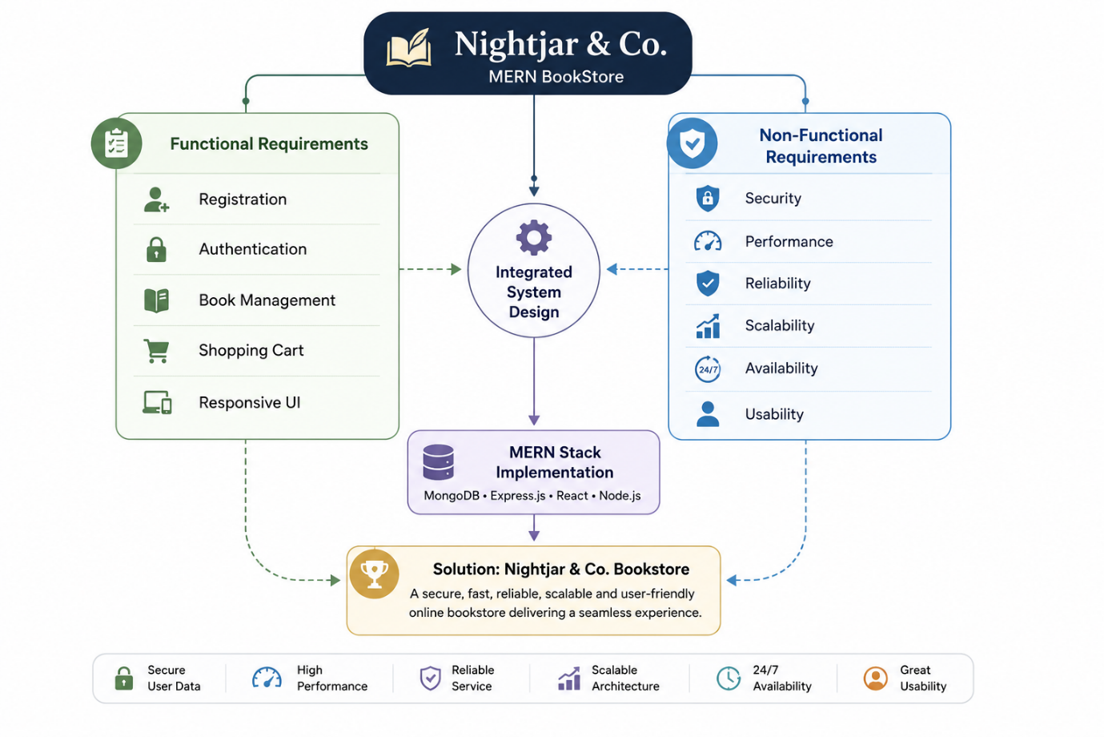
Figure 1 : Functional and Non-Functional Requirements

